
How to Setup Thunderbird

Download and install Thunderbird eMail program

Once the program starts it will open the Mail Account Setup
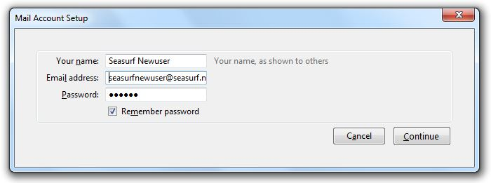
Enter the name that you want to show up as the “From” when you send an eMail.
Next your eMail address, and password then before you click “Continue”
Be ready to click “Stop” once the next window appears.

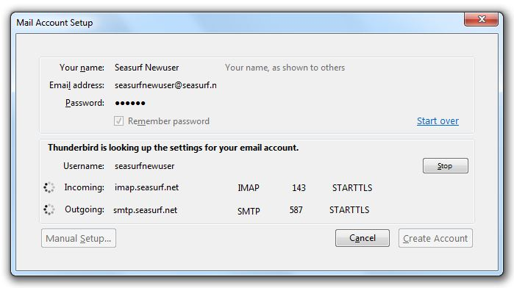
Once you have clicked STOP we will need to make some changes

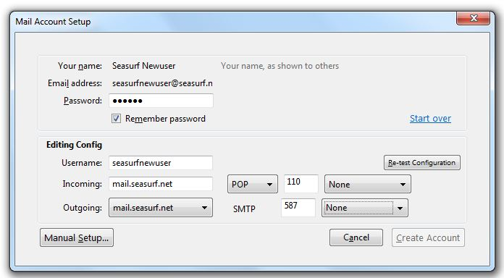
Change both Incoming, and Outgoing to “mail.seasurf.net”
Match all the settings as shown above, and then click “Manual Setup”

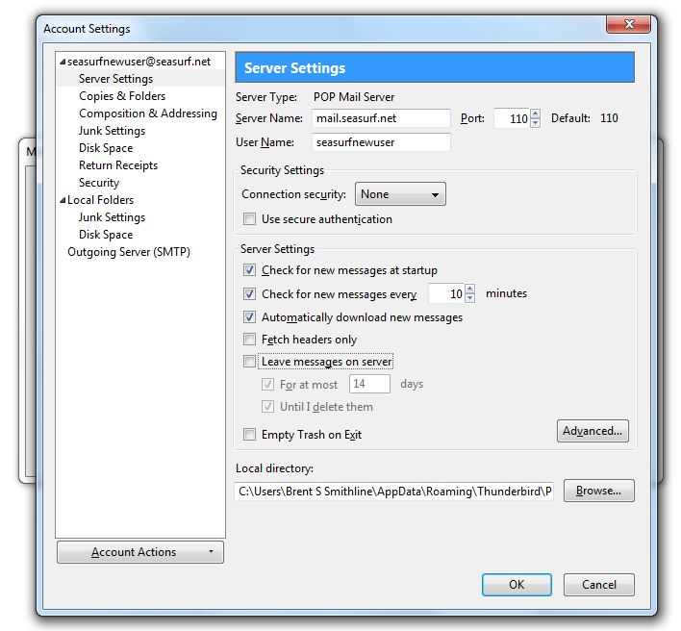
Next click “Server Setting” along the left side, and uncheck “Leave messages on server”
Now click “Outgoing Server (SMTP)” along the left side

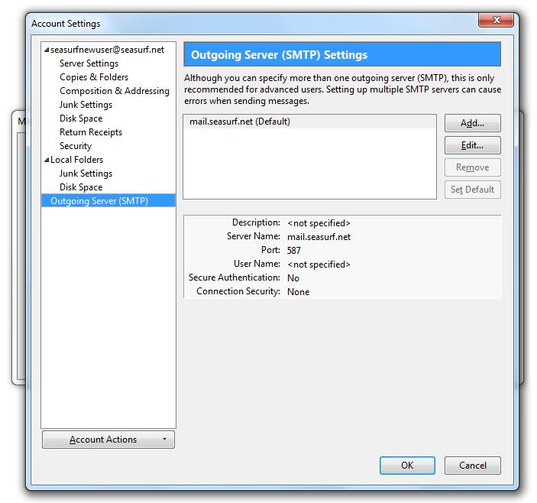
Now click “Edit” on the right hand side

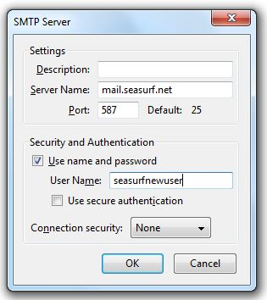
Now click “Use name and password” and enter your “User Name”, and click OK

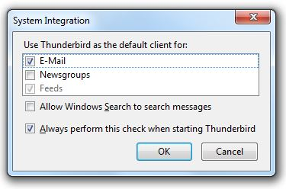
Next if you wish to have Thunderbird as your default eMail client click “OK”

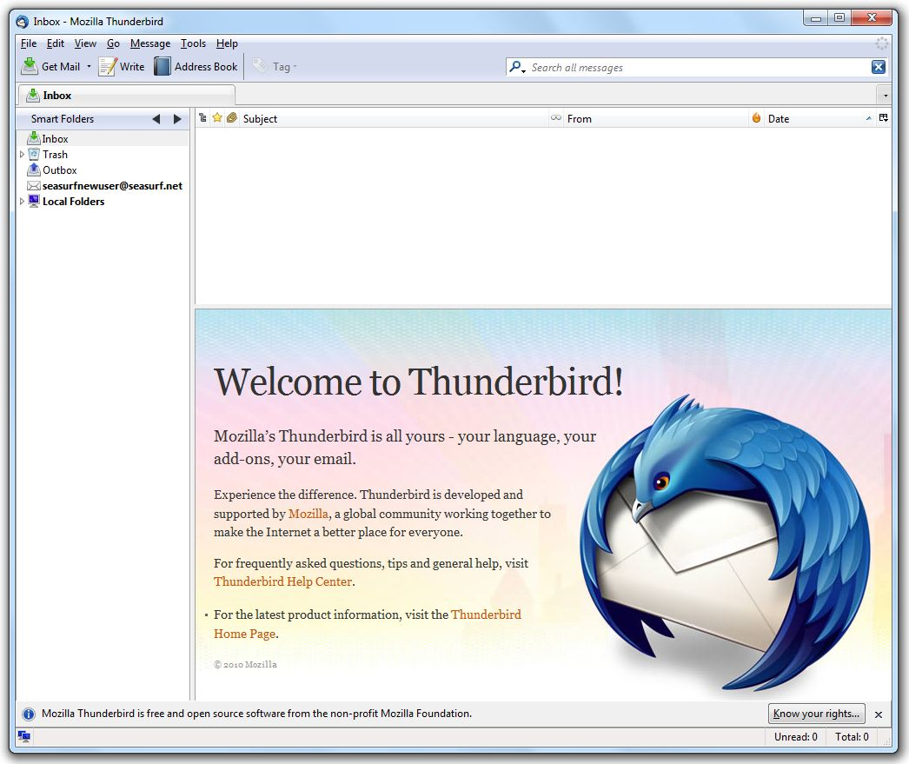

Congratulations your are now ready to use Thunderbird

©2000-2010 Seasurf Internet a division of Internet Partners, Inc.
1800 NW 167th Place Suite 160
Beaverton, Oregon 97006-8132
Phone Seaside +1 800 445 0193
Phone Beaverton +1 503 690 2700 FAX +1 503 690 9700

