
How to Check the Setup of Thunderbird

Open Thunderbird eMail program

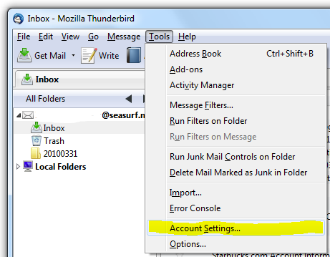

Choose Tools , Account Settings...

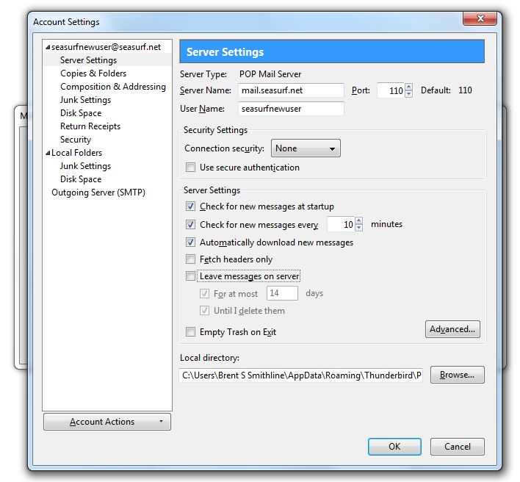
Next click “Server Setting” along the left side, and uncheck if checked “Leave messages on server”

Now click “Outgoing Server (SMTP)” along the left side

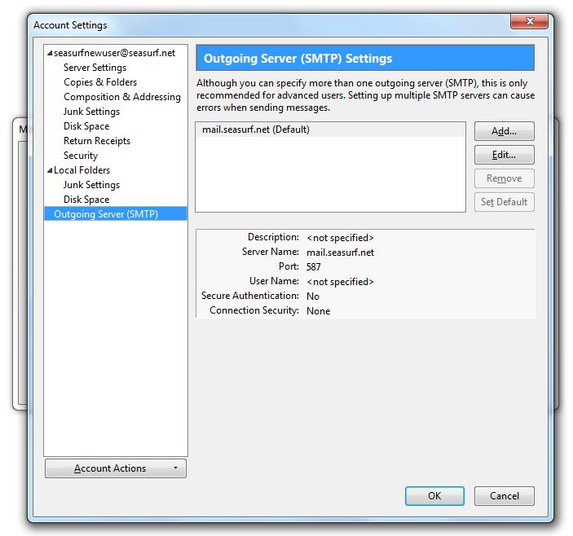
Now click “Edit” on the right hand side

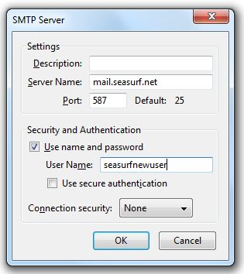

Now click “Use name and password” and enter your “User Name”, and click OK

©2000-2010 Seasurf Internet a division of Internet Partners, Inc.
1800 NW 167th Place Suite 160
Beaverton, Oregon 97006-8132
Phone Seaside +1 800 445 0193
Phone Beaverton +1 503 690 2700 FAX +1 503 690 9700

